FORMAL OBJECTION LETTER
To: Texas Commission on Environmental Quality
Office of the Chief Clerk
Mail Code MC-105
P.O. Box 13087
Austin, TX 78711-3087
Email: chiefclk@tceq.texas.gov
Date: 04/10/2025
Subject: Formal Objection and Request for Contested Case Hearing
Re: Permit No. WQ0016736001 – Liberty County MUD No. 15 – Tarkington WWTP #1

Dear TCEQ Commissioners,
We, Kelly Dishman and Kathy Smith, legal owners and residents of the properties located at 145 County Road 2223 and 141 County Road 2223, Cleveland, Texas 77327, submit this formal objection to the above-referenced wastewater discharge permit and formally request a Contested Case Hearing.
Statement of Concern: Our homes lie within approximately 1.25 miles of the proposed Tarkington Wastewater Treatment Plant (WWTP #1). The properties are located directly on County Road 2223 in the Tarkington Woods subdivision—a residential corridor that includes homes on CR 2235 and CR 2518. Residents in this area have already experienced flooding events, with water reaching or nearly reaching homes during past storms.
The proposed discharge of 245,000 gallons per day of treated wastewater presents significant risks, including:
- Increased surface water runoff and localized flooding along CR 2223–2235 and CR 2518;
- Threats to private drinking water wells, especially under high rainfall or system failure;
- Air quality concerns due to potential odor drift over rural properties;
- Devaluation of surrounding properties due to nuisance proximity and environmental uncertainty;
- Ecological impact on ponds, drainage swales, and livestock areas.
Inconsistencies in Discharge Route Description: We request that the Texas Commission on Environmental Quality provide immediate clarification regarding conflicting statements in the application. While one section (Administrative Report, p. 8) claims the discharge will occur “via pipe to an unnamed tributary,” another section (Technical Report, p. 26) identifies the receiving water as a “man-made channel or ditch,” with no continuous flow and observed to be dry under typical conditions.
These inconsistencies must be resolved prior to permitting. If the outfall discharges into a manmade ditch, it must be modeled for overflow, bank failure, and downstream flooding impacts — particularly to residences at CR 2518 and CR 2223, where flooding has historically occurred. TCEQ should require a formal H&H study and a revised public impact buffer zone to include all affected properties along this outfall path.
Statement of Request: We respectfully request that TCEQ:
- Expand the impact study and public notice area to encompass all downstream drainage impact zones;
- Allow affected residents—including those at and around CR 2223, CR 2235, and CR 2518—to voice concerns in a contested case hearing;
- Require updated flood modeling and site-specific environmental analysis;
- Apply robust mitigation and long-term monitoring requirements if approval proceeds.
We urge TCEQ to fully evaluate how this project affects families who have long called this land home. Please see the satellite imagery below to reflect on the situation genuinely.

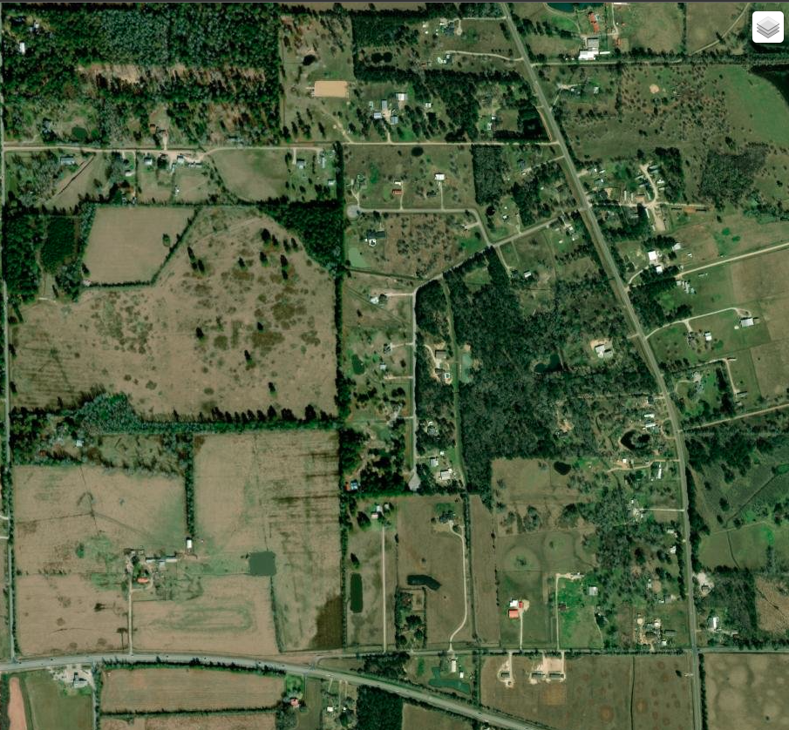
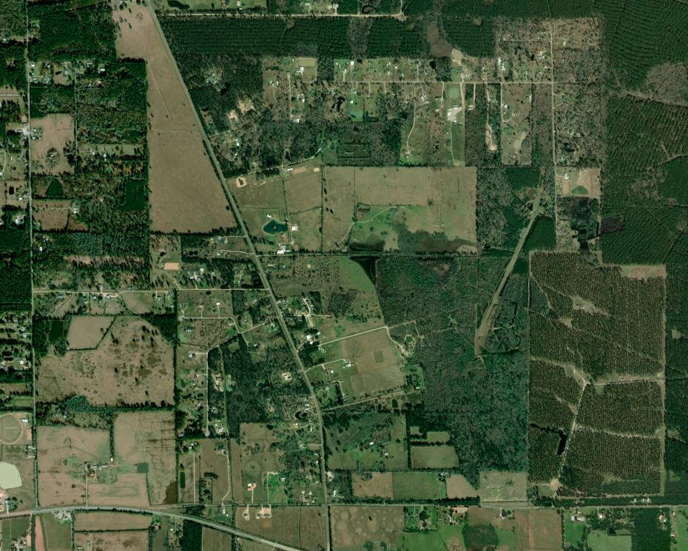

Sincerely,
Kelly Dishman
145 County Road 2223
Cleveland, TX 77327
Email: kellyldishman84@gmail.com
Phone: 281-299-7238
Kathy Smith
141 County Road 2223
Cleveland, TX 77327
Email: deolgoatlady@gmail.com
Phone: 281-299-7238

